**Heap Memory Stack memory**

10

Student s=new Student();

s.sno=10;

s.GetData();

Student s1=new Student();

10

import java.util.*;

class Student

{

int sno;String sname;float avg;

public void GetData()

{

System.out.println("Enter Number Name and Average Marks");

Scanner sc=new Scanner(System.in);

sno=sc.nextInt();

sname=sc.next();

avg=sc.nextFloat();

}

public void Display()

{

System.out.println("Number:"+sno+" Name:"+sname+" Average :"+avg);

}

public static void End()

{

System.out.println("Reading is Ended");

}

public static void main(String args[])

{

Student.End();

Student s=new Student();

Student s1=new Student();

s.GetData();

s1.GetData();

System.out.println("_______________________");

System.out.println("NO Name average");

System.out.println("_______________________");

s.Display();

s1.Display();

}

}

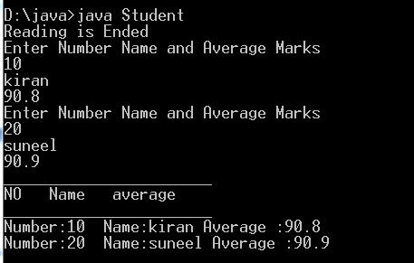

Initialization of class members

class Demo

{

int a;

public void Display()

{

System.out.println(" a values is"+a);

}

}

class Demo1

{

0

public static void main(String args[])

{

Demo o=new Demo();

o.Display();

}

}

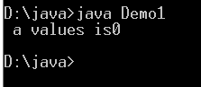

class Demo

{

int a=10;

public void Display()

{

10

System.out.println(" a values is"+a);

}

}

class Demo1

{

public static void main(String args[])

{

Demo o=new Demo();

o.Display();

}

}

Default constructor:

class Demo

{

int a;

public Demo()

{

a=100;

}

public void Display()

{

System.out.println(" a values is"+a);

}

}

class Demo1

{

public static void main(String args[])

{

100

Demo o=new Demo();

Demo o1=new Demo();

100

o.Display();

}

}

Paramertized constructor

class Demo

{

int a;

public Demo(int x)

{

a=x;

}

public void Display()

{

System.out.println(" a values is"+a);

}

}

class Demo1

{

public static void main(String args[])

{

Demo o=new Demo(100);

Demo o1=new Demo(200);

o.Display();o1.Display();

}

}

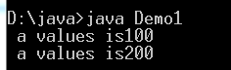

class Demo

{

int a;

public Demo(int x)

{

a=x;

}

public Demo(Demo obj)

{

a=obj.a;

}

public void Display()

{

System.out.println(" a values is"+a);

}

}

class Demo1

{

1000

200

1000

public static void main(String args[])

{

Demo o=new Demo(1000);

Demo o1=new Demo(200);

Demo o2=new Demo(o);

o.Display();o1.Display();o2.Display();

}

}